15.15: a) Neglecting the mass of the string, the tension in the string is the weight of the pulley, and the speed of a transverse wave on the string is

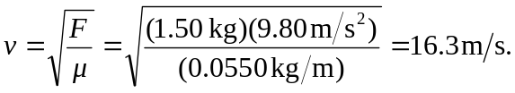

b) c) The speed is proportional to the square root of the tension, and hence to the square root of the suspended mass; the answers change by a factor of 